Shamrock Friend Craft
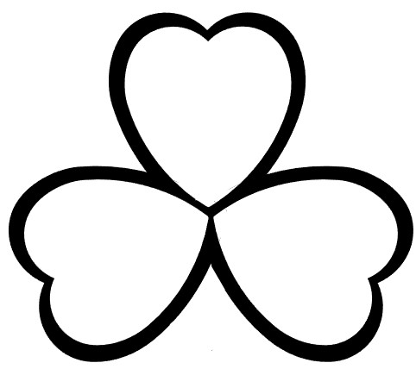
Body
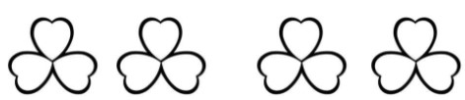
Foot
Foot
Hand
Hand

